White Wine with some upsampling and down sampling

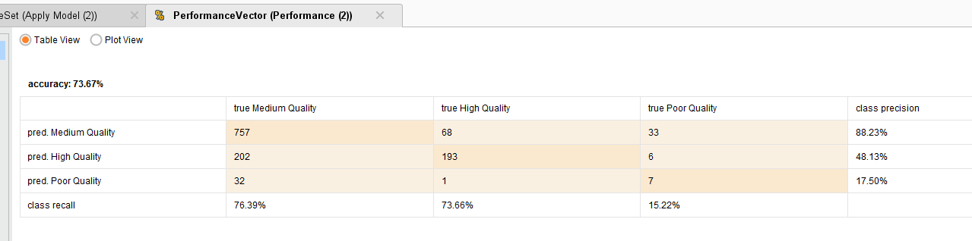

Only down sampling of white..

